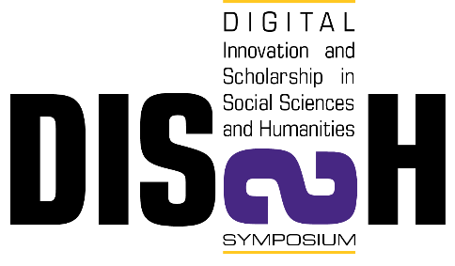 | Third Annual DISSH Symposium  Faulkner Gallery, Joyner Library,  East Carolina University  March 16, 2017

SESSION III 11:00-11:30
Digital Poster-Laptop Session (on display until 5:00)

“Centering Spenser”
Tom Herron, Thomas Harriot College of Arts and Sciences
Laurie Godwin, Information Technology and Computing Services
Joyce Newman, Office for Faculty Excellence
http://core.ecu.edu/munster
“Digital Barcelona”
Benjamin Fraser, Thomas Harriot College of Arts and Sciences
Irina Swain, Thomas Harriot College of Arts and Sciences
Camille Kresz
http://collections.ecu.edu/exhibits/show/digital-barcelona2017
“Avant-Gardes”
FREN 3560 spring 2016: https://collections.ecu.edu/neatline/show/historique-avant-garde.
“Story Maps”
Modern Greek CLAS 4000 spring 2015: http://arcg.is/1K5G7wN.
Marylaura Papalas, Thomas Harriot College of Arts and Sciences
“The Allen Parker Slave Narrative Website”
Joyce Newman, Office for Faculty Excellence
http://core.ecu.edu/newmanj/cecelskid/

